Climate Change

What is Climate change?

those variations that persist for a longer period of time, typically decades or more. In the time since the [industrial revolution](https://en.wikipedia.org/wiki/Industrial_revolution) the climate has increasingly been affected by [human activities](https://en.wikipedia.org/wiki/Human_impact_on_the_environment) that are causing [global warming and climate change](https://en.wikipedia.org/wiki/Climate_change).[[1]](https://en.wikipedia.org/wiki/Climate_variability_and_change#cite_note-1)<https://en.wikipedia.org/wiki/Climate_variability_and_change>

what are our insights?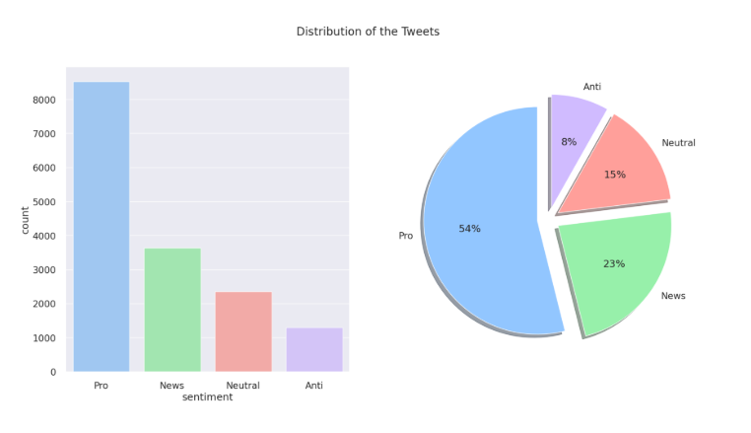

from our analysis we can see that the majority of tweets are actually pro climate change meaning people are aware of climate change and it’s existence with only 8% saying otherwise.

What are the most words used?

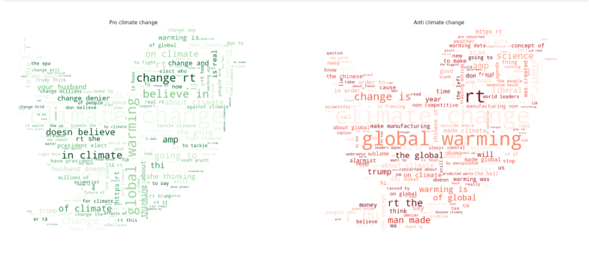

These are the most frequently used words in the tweets on the left we have pro and on the right we have Anti

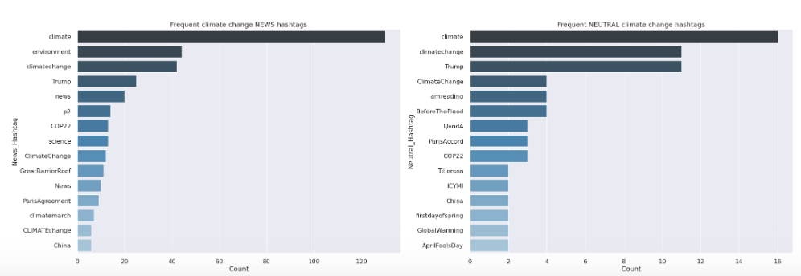here we have the most used hashtags in the news

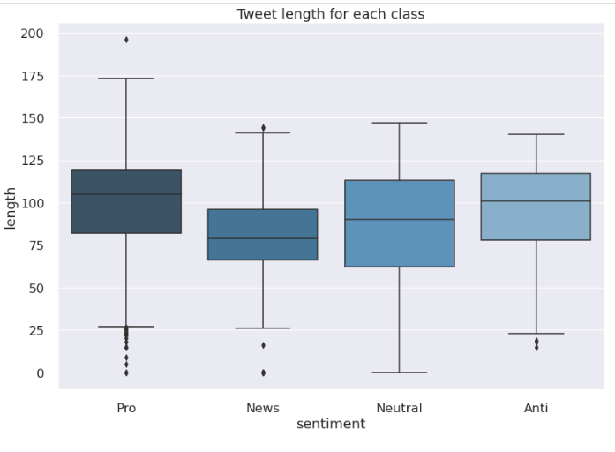

Here we have our sentime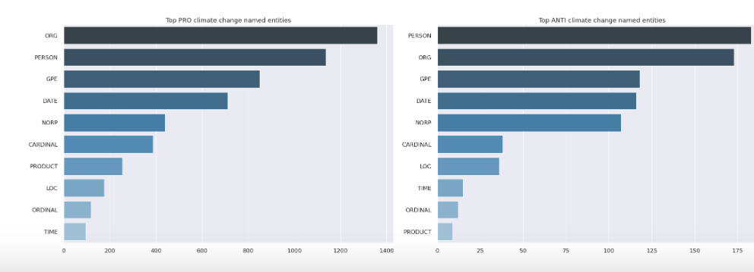

Below we have our top emojis

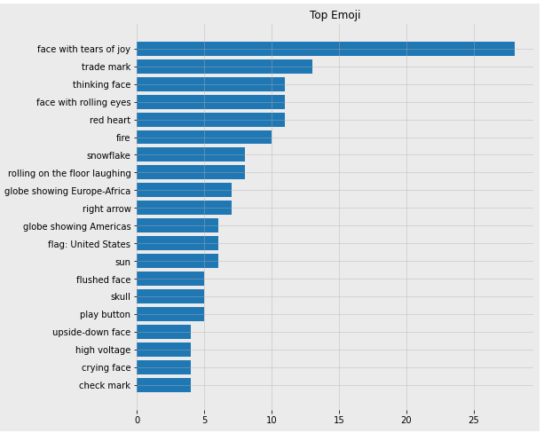

Below we have top mentioned

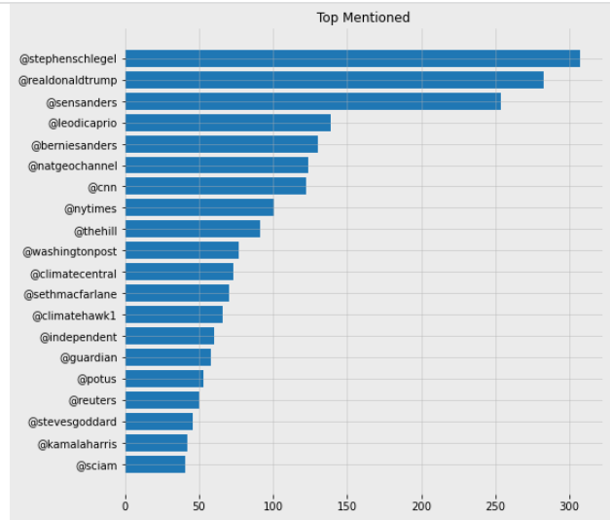

Below we have top hashtags

